Identifying, Investigating and Prosecuting
Domestic Violence STRANGULATION Cases

Tues 8th June 2021
2pm – 5:30pm

Weds 9th June 2021
2pm – 6:45pm

Via Zoom
£55 each for 2-day training

For more information about this training, contact: Louisa Young louisa.young@foylewomensaid.org

In partnership with
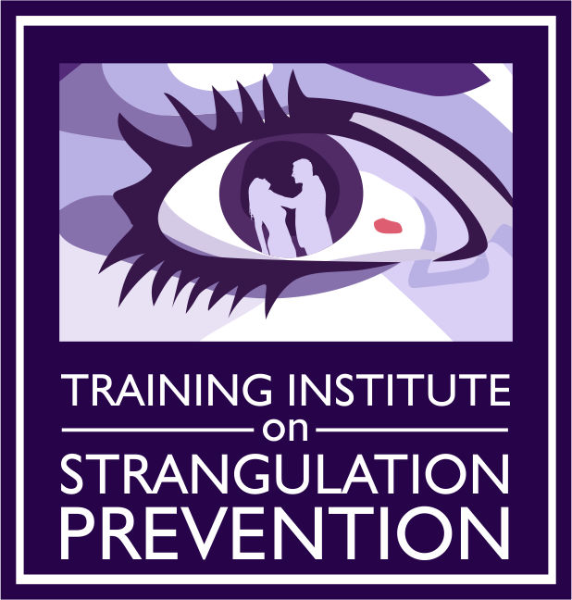
Training Institute on Strangulation Prevention www.strangulationtraininginstitute.com

SPONSORED BY
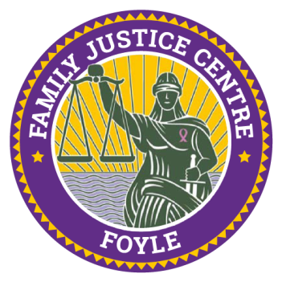

.

S
trangulation has been identified as one of the most lethal forms of domestic violence and sexual assault: unconsciousness may occur within seconds and death within minutes. When domestic violence perpetrators choke (strangle) their victims, not only is this felonious assault, but it may be an attempted homicide. Strangulation is an ultimate form of power and control, where the batterer can demonstrate control over the victim’s next breath; it may have devastating psychological effects or a potentially fatal outcome.
COURSE DESCRIPTION
Gael Strack, J.D. Strangulation Institute San Diego, is a leading expert in the field of non-fatal strangulation and suffocation assaults in intimate partner violence cases, who will share her expertise and cover the following:
- Findings from a study of 300 misdemeanour strangulation cases
- Understanding the lethality of strangulation
- Identifying the signs and symptoms of strangulation cases
- Anatomy and medical aspects in surviving and non-surviving victims
- Investigating and documenting Domestic Violence and Sexual Assault Strangulation cases for prosecution
- Legal aspects of strangulation cases with surviving victims
- Tools and resources for advocates
- Developing and using experts in court
- Resources and handouts developed by the Institute
“For many years, we didn’t realise the seriousness of strangulation due to the lack of visible injuries and the lack of training. We would see it in police reports and hear victims say over and over, ‘He choked me’. But it wasn’t until the deaths of two teenagers in San Diego in 1995 that we started to put it all together. Today, we know that strangulation is one of the most accurate predictors for a subsequent homicide. If a victim is strangled even one time, she is 7x more likely to be killed by her abuser. Even If the victim is lucky enough to survive, she may have still suffered brain damage due to the lack of oxygen, other internal injuries, delayed or long-term consequences.”
Gael Strack, Esq., CEO & Casey Gwinn, Esq., President
Alliance for HOPE International & the Strangulation Training Institute on Strangulation Prevention
WHO SHOULD ATTEND: Any professional handling sexual assault, domestic violence, child abuse, elder abuse or human trafficking. (Police, Legal Professionals, Judges, Lawyers, Solicitors, Court Staff, Probation, Support Workers, Medical Providers, Paramedics, Advocates, Psychologists)

